ackaging & Delivery

Packaging Details

Bag or Box

Delivery Time

Within 3 working days after the money arrived

Product Type: GDC03077  
Dimensions: 37.0x29.0x2.8mm  
Horizon Size: 34.6x22.6mm  
Connection: PIN (metal pins)  
Perspective: 12 O'CLOCK  
Drive mode: 1/8 DUTY, 1/4 BIAS  
Driving voltage: 3.15V  
Operating temperature: -40 C ~ 70 C  
Polaroid Type: is significant, reflecting  
Backlight: No

=========================================================================================

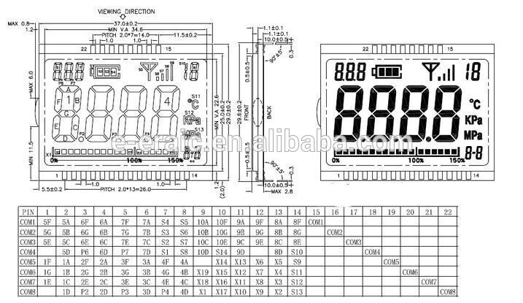

https://ru.aliexpress.com/item/White-SMD-LED-Bakclight-Pin-Connection-Metal-3-0V-15mA-For-GDC03077-LCD-Display-Accessories/32764072285.html?spm=a2g0v.10010108.1000016.1.76aaff84R4pXLp&isOrigTitle=true